
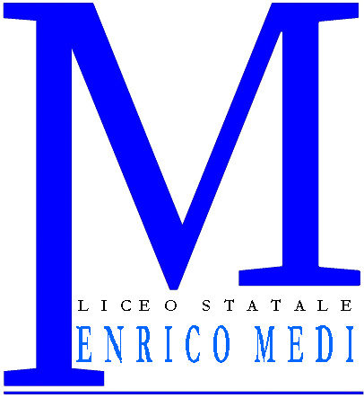
LICEO SCIENTIFICO STATALE “ENRICO MEDI”
CON INDIRIZZI: SCIENTIFICO – LINGUISTICO – SOCIO * PSICO * PEDAGOGICO – CLASSICO
Sede: VIA MAGENTA, 7/A - 37069 VILLAFRANCA dI VERONA - Tel. 045.7902067 Fax : 045.6300817
e-mail sede: info@liceomedi.com - Preside : preside@liceomedi.com
Sito http://www.liceomedi.com
C.F. 80014060232
________________________________________________________________________________________________________________________________________________________________________________________________________________________________________________________________________________________________________________________________________________________________________________________________________________________________________________________________________________________________________________________________________________________________________________________________________________________________________________________________________________________________________________________________________

Programmi svolti anno scolastico 2007/2008

Docente Materia: classe

Testo in adozione:

Programma svolto -

I Rappresentanti di classe Prof./ssa
_________________________ __________________________
_______________________

Villafranca di Verona _____________________________

